Please join us for an Open House and CrossFit Demo Workout
When: Saturday, December 12th 1:00 – 4:00 p.m.
Where: inov-8 office and warehouse
10 Southville Road
Southborough, MA 01772
508-480-8856

Network with local runners, CrossFitters and hikers. Treats and beverages will be served. Raffles held every hour. Take advantage of discounts on merchandise.

Other local companies will be showing and raffling their products


Find out why so many runner’s are excited about CrossFit’s approach to total fitness

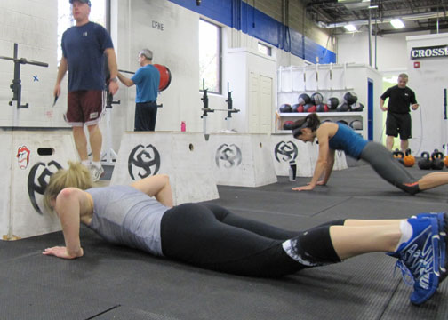
Have fun doing your daily workout
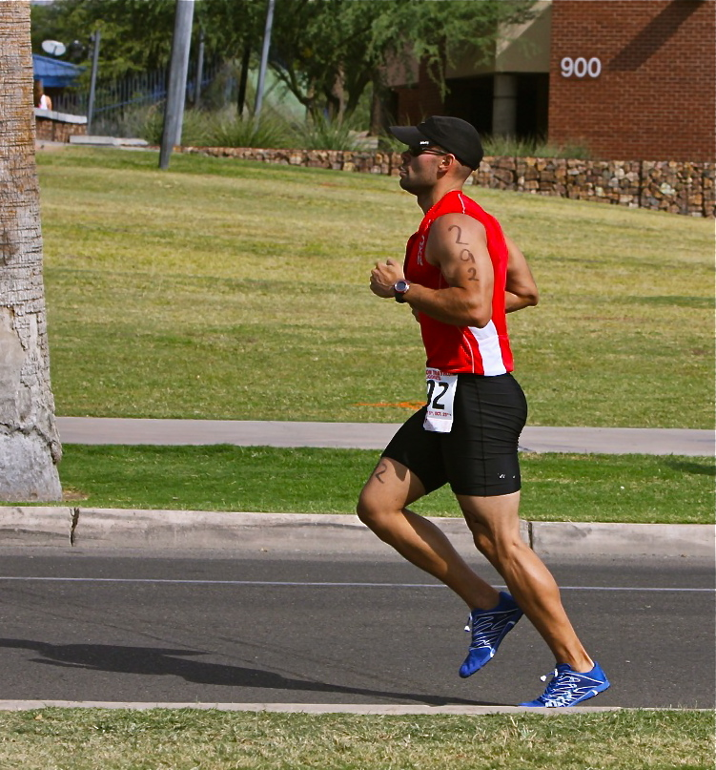
Learn more about the POSE Method of running
www.crossfitnewengland.com
www.crossfitnewengland.com

